**ToDoList说明文档**

1. **Functional analysis：**
2. **Register、The login、The cancellation**

To enable a user to create his TODO list, set up a system for registering, logging in, and logging out users. To create an account, the user will have to provide a nickname, an E-mail address, and a password. Nicknames and E-mail addresses must be unique, so you need to check their availability when you create an account.

1. **The home page**

After the user logs in to the site, he goes to its home page. This will contain Shared notifications as well as all of the user's to-do lists and to-do lists Shared with him.

* Accept or reject requests to share TODO lists
* Create a new to-do list
* Delete the to-do list
* Click on the existing TODO list to modify it

1. **TODO list page**

* The TODO list will contain two sections: "Ongoing tasks" and "Completed tasks"
* The ability to display all tasks or only current tasks or completed tasks
* Add/remove items to/from the to-do list without reloading the page to see the changes
* Switch the task item from the current task to the completed task
* Check all task buttons at once
* Delete all completed buttons at once

1. **Unit testing**

Unit testing the application using the PHPUnit framework.

1. **The flow chart：**

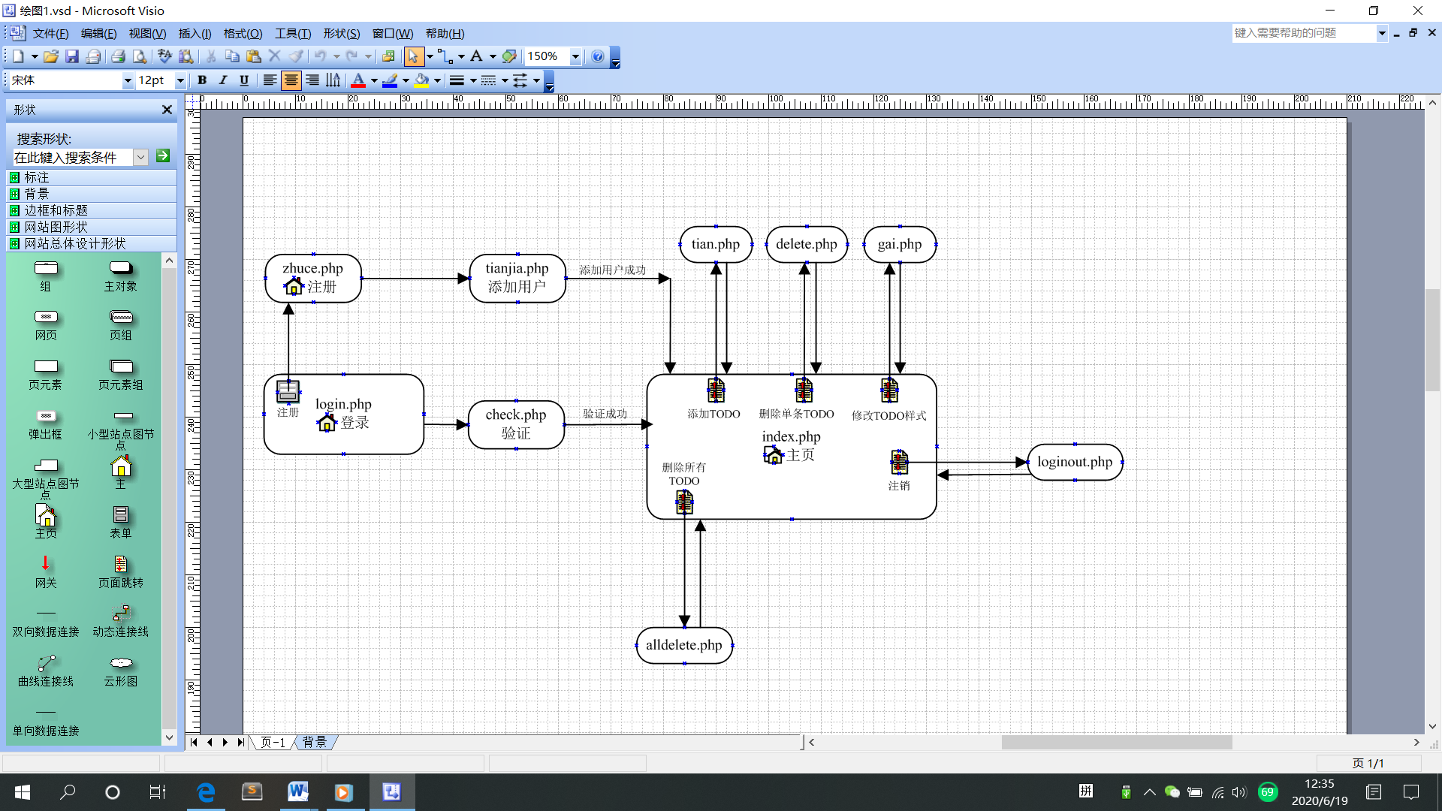

1. **The database：**

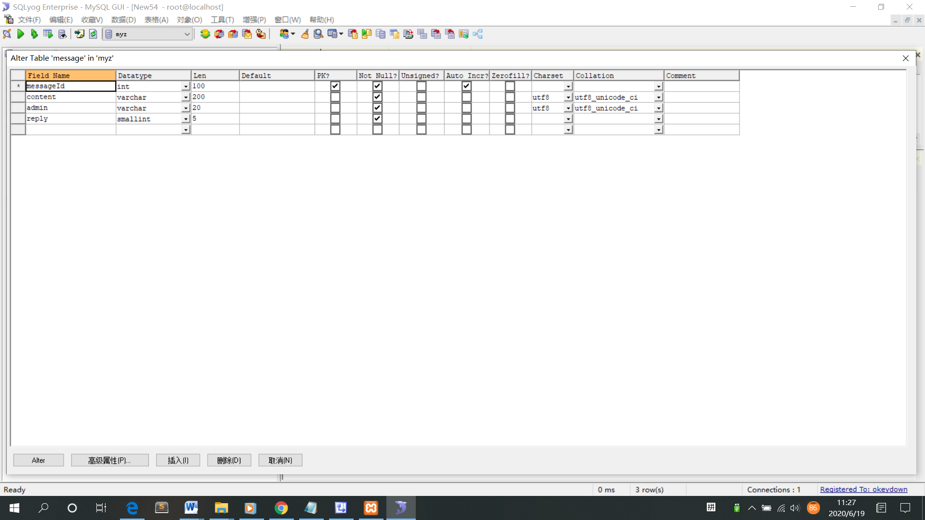

message

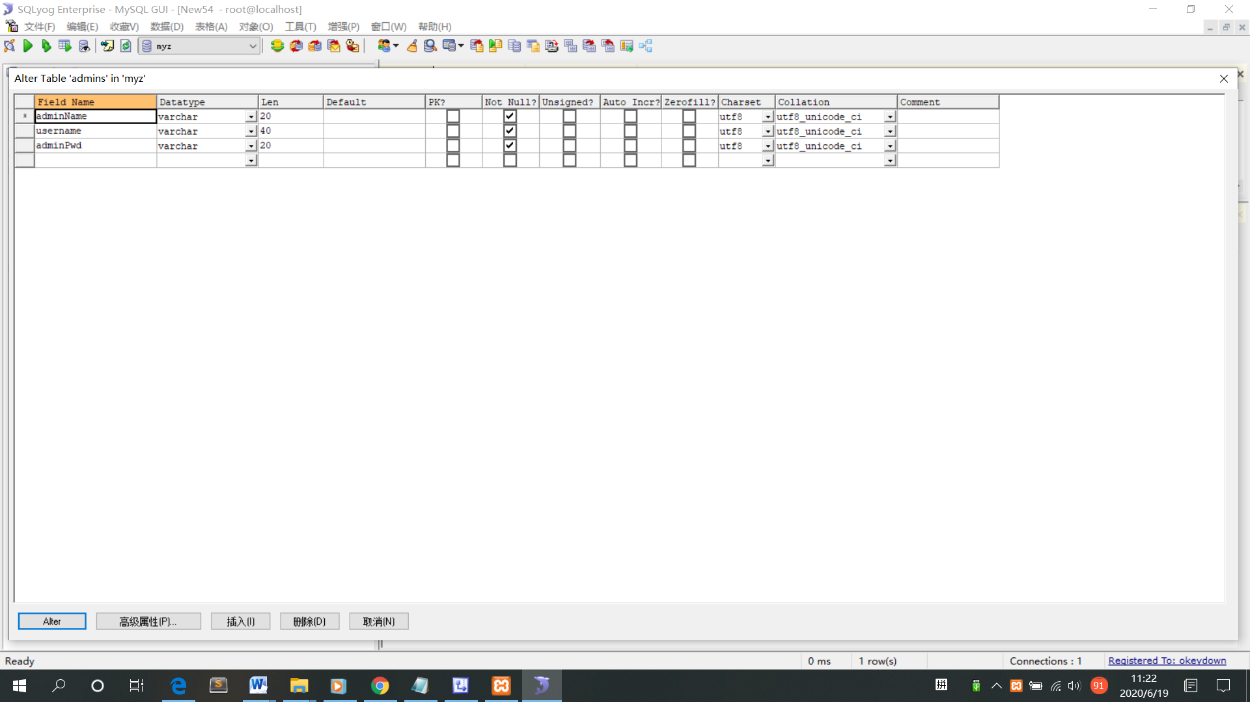

Admins

1. **Module is introduced（code）：**
   1. **login.php**

The home page is the login page. Users fill in the correct nickname and password and then go to the TODO home page. If the user does not enter or input error, after submitting, the pop-up dialog box will prompt the user information is not correct.

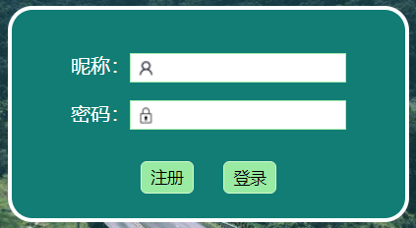 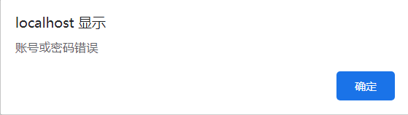

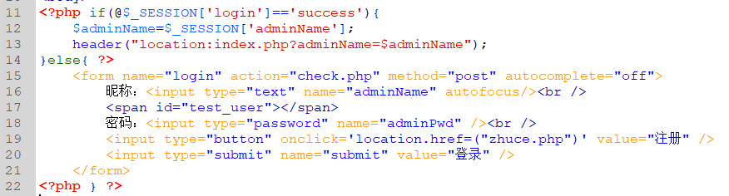

* 1. **conn.php**

The CONN profile is used to connect to a backend database.

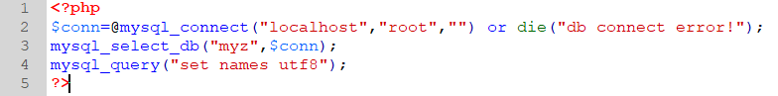

* 1. **check.php**

Check whether the weight and password are correct, then go to the index homepage. 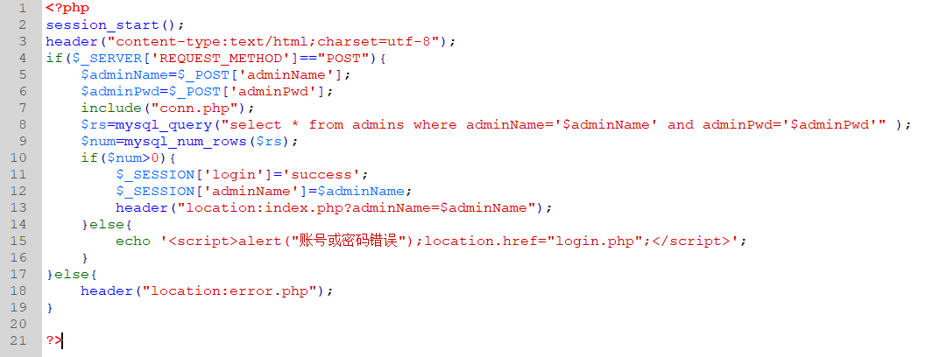

* 1. **zhuce.php**

If the user does not enter or enters the wrong information, the pop-up dialog box will prompt the user that the information is incorrect. If the registration is successful, it will jump to the index homepage. Add a TODO

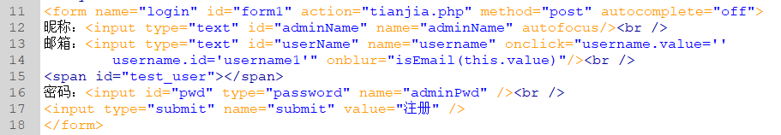

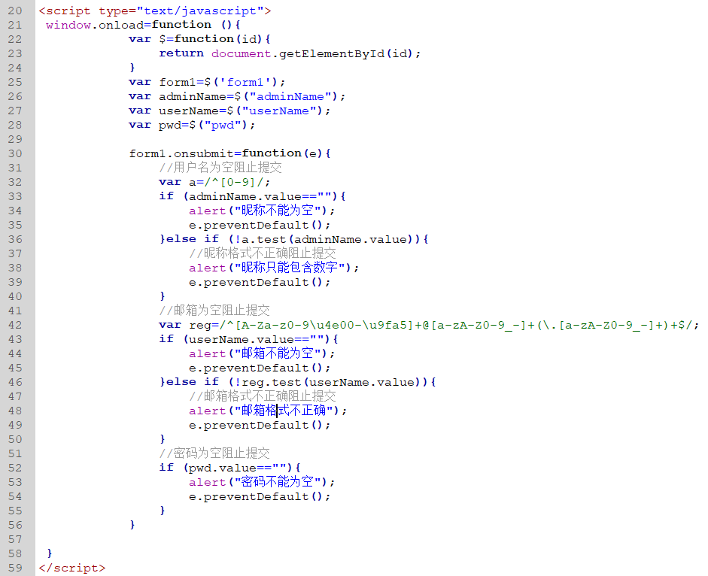



* 1. **tianjia.php**

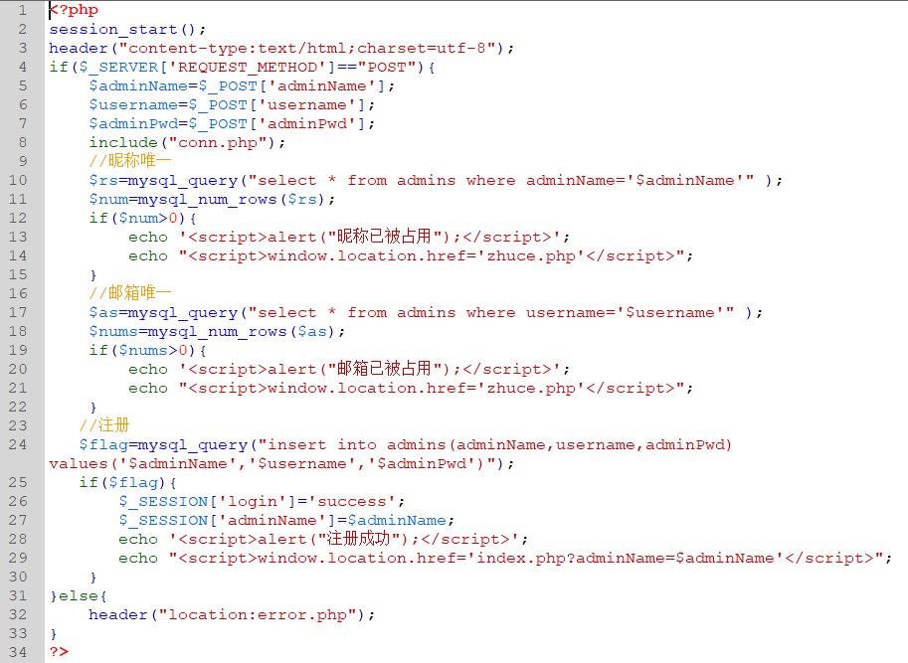

* 1. **index.php**

TODO home page

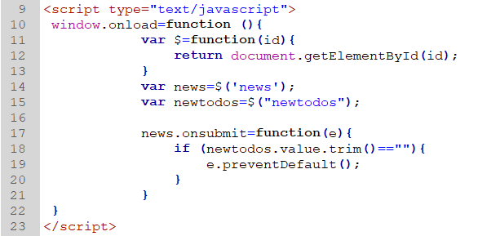

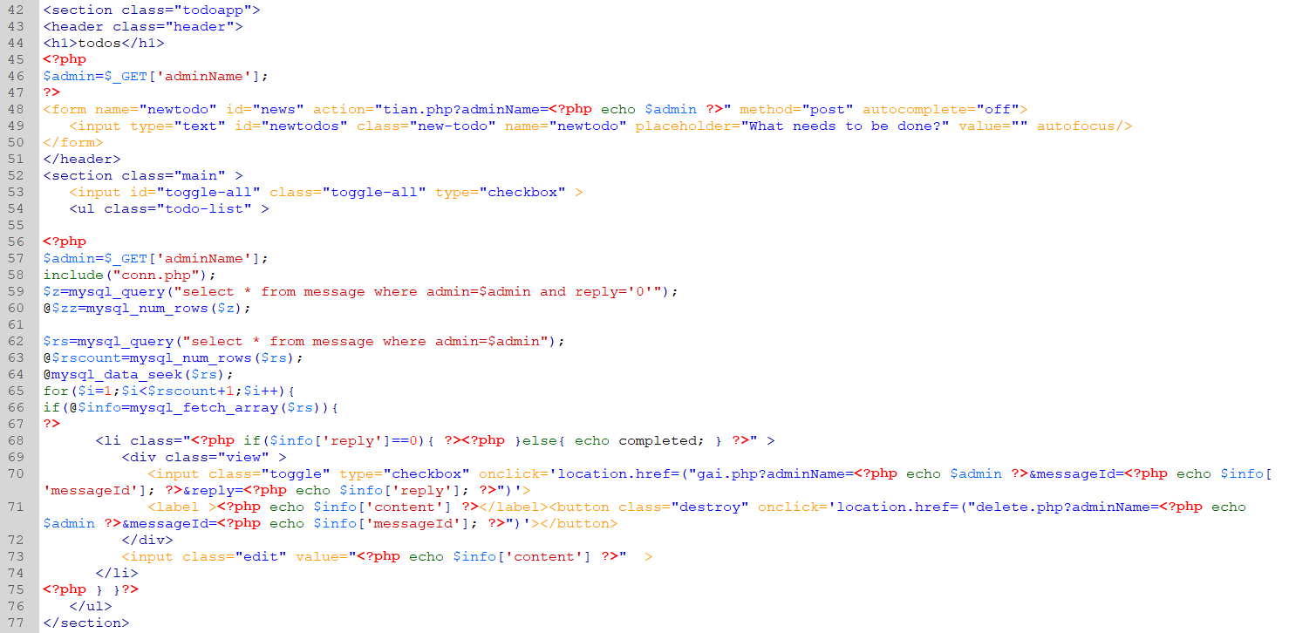

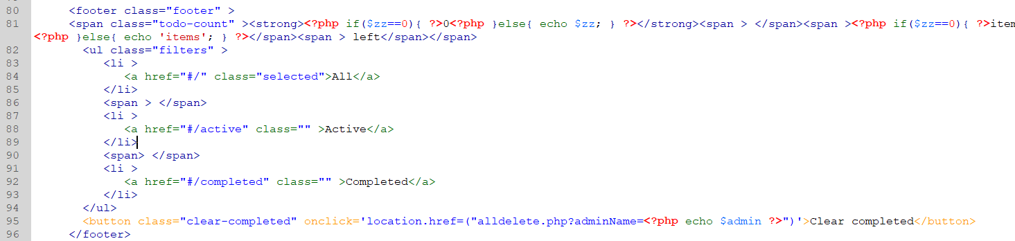

* 1. **tian.php**

Add a TODO

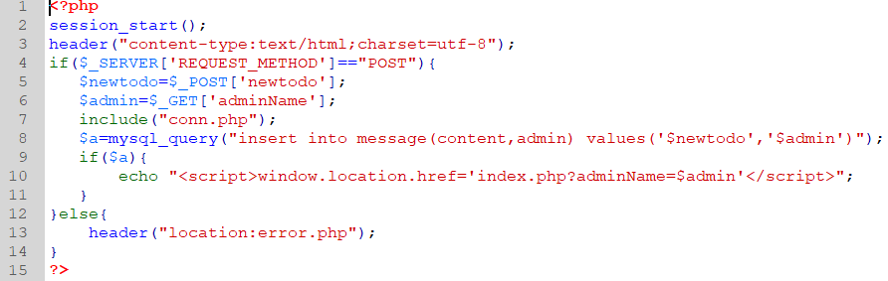

* 1. **delete.php**

Delete this article TODO.

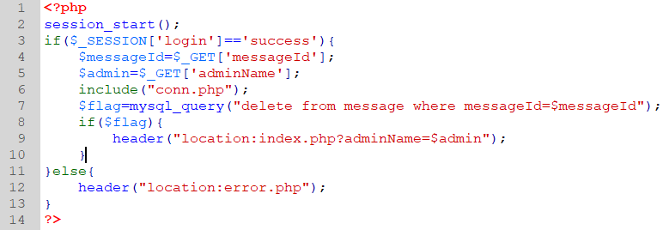

* 1. **alldelete.php**

Delete all todos.

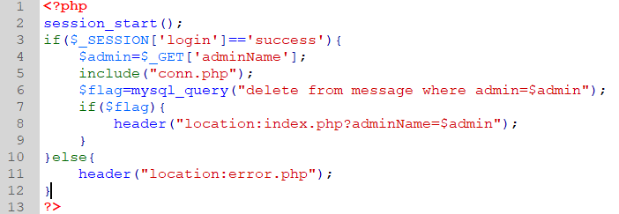

* 1. **gai.php**

Modify the TODO state

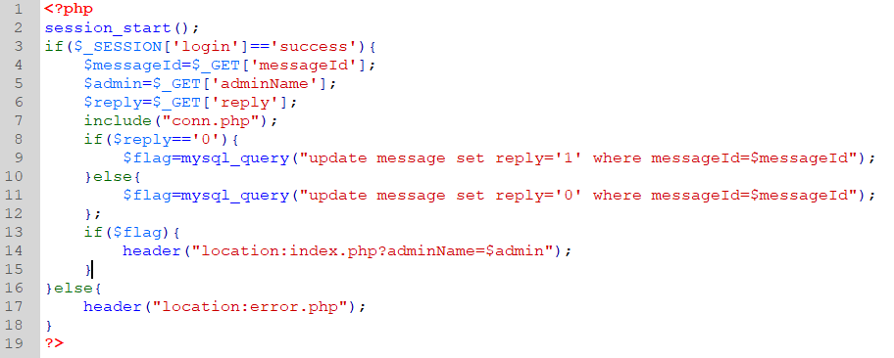

* 1. **loginout.php**

The cancellation of the use.

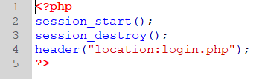

1. **Directions for use：**
   1. **Click the Register button**

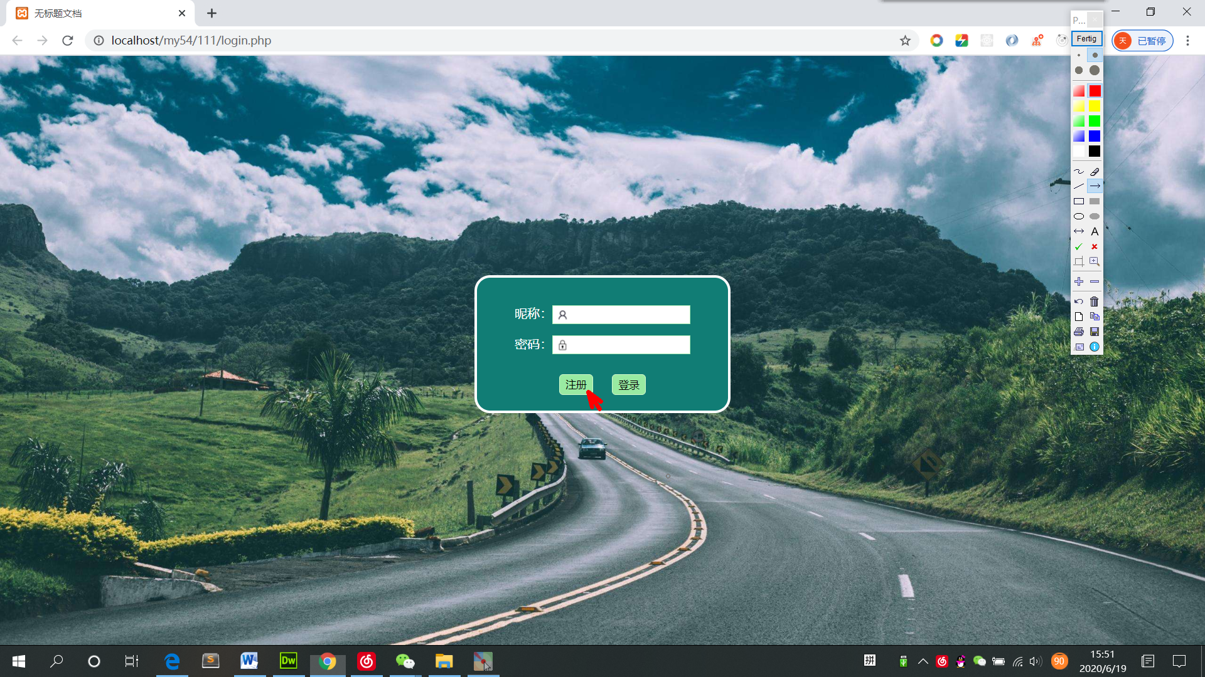

* 1. **Enter the nickname, mailbox and password (nickname and mailbox must be unique and not occupied）**

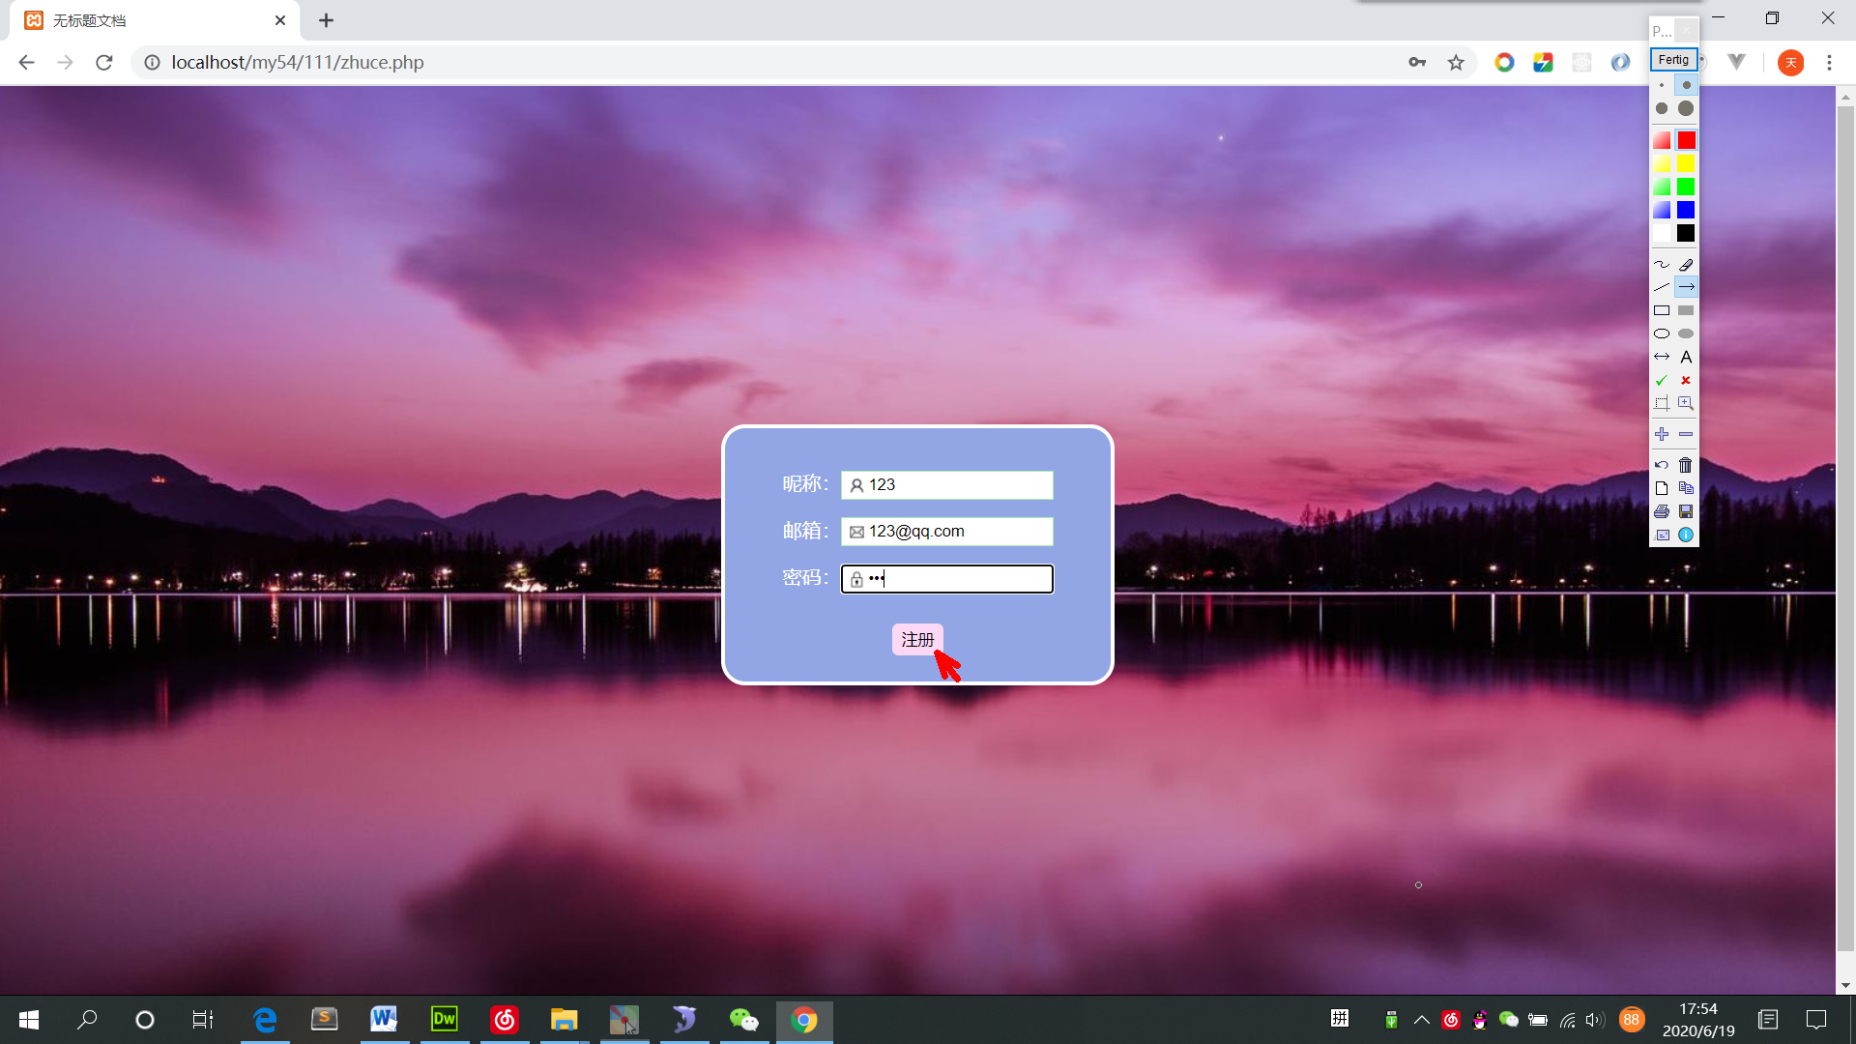

* 1. **Enter TODO in the input box and press Enter**

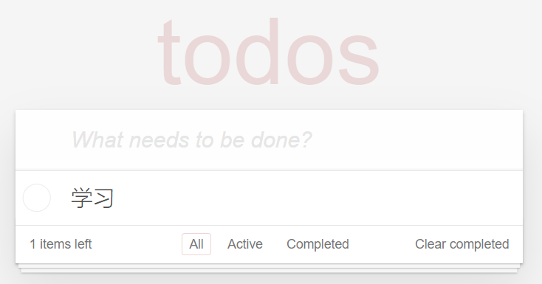

* 1. **Mouse over the added TODO and click the "×" button on the right to delete this TODO**

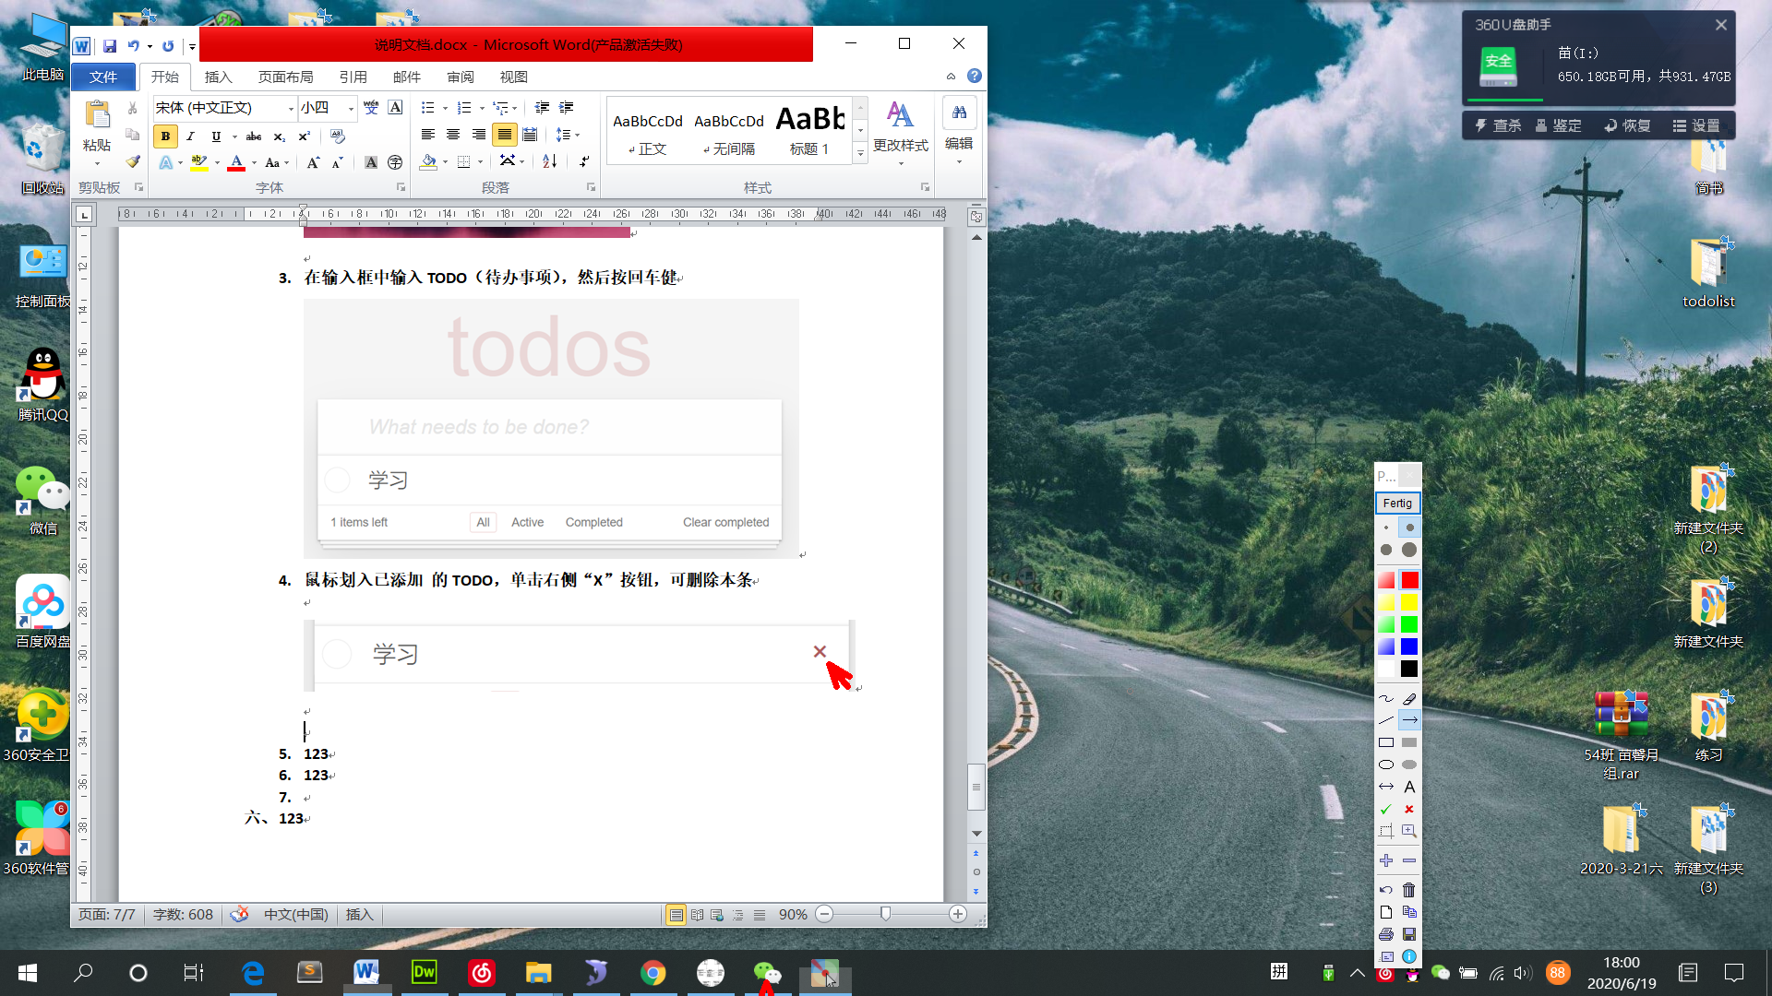

* 1. **Click the "Clean Completed" button in the lower right corner to delete all toDos**

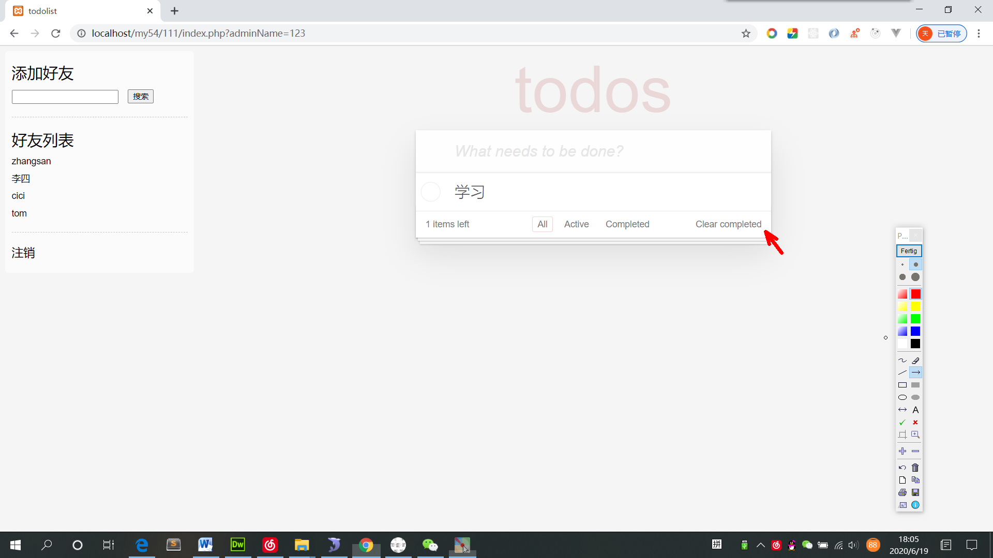

* 1. **Click the circular button to the left of TODO to change the TODO state – completed**

